Project Design Phase-II
Data Flow Diagram & User Stories

Date | 11 July 2026
Team ID
Project Name | House Rent Management System
Maximum Marks | 4 Marks

Data Flow Diagrams:
A Data Flow Diagram (DFD) is a traditional visual representation of the information flows within a system. A neat and clear DFD can depict the right amount of the system requirement graphically. It shows how data enters and leaves the system, what changes the information, and where data is stored.
Example: DFD Level 0 (Industry Standard)
Example: (Simplified)
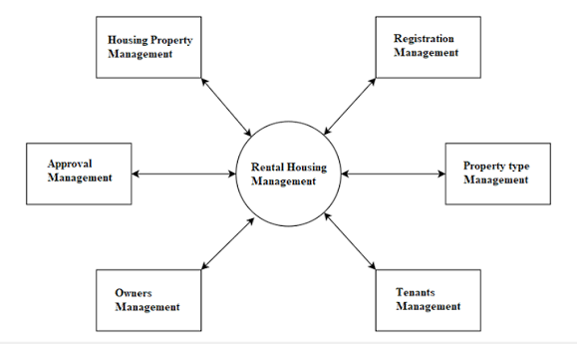


2. User Stories
User Type | Functional Requirement (Epic) | User Story No. | User Story / Task | Acceptance Criteria | Priority | Release
Customer (Web User) | Registration | USN-1 | As a user, I can register using my name, email, and password. | User account is created successfully. | High | Sprint-1
Customer (Web User) | Login | USN-2 | As a user, I can log in using my email and password. | User is redirected to the dashboard after successful login. | High | Sprint-1
Customer (Web User) | Authentication | USN-3 | As a user, I receive a JWT token after login. | Protected routes are accessible only after authentication. | High | Sprint-1
Customer (Web User) | Property Listing | USN-4 | As a user, I can view all available rental properties. | Property list is displayed successfully. | High | Sprint-2
Customer (Web User) | Property Details | USN-5 | As a user, I can view complete details of a selected property. | Complete property information is displayed correctly. | High | Sprint-2
Customer (Web User) | Property Search | USN-6 | As a user, I can search properties by location. | Matching properties are displayed. | High | Sprint-3
Customer (Web User) | Property Filter | USN-7 | As a user, I can filter properties by property type and maximum rent. | Filtered properties are displayed correctly. | High | Sprint-3
Customer (Web User) | Booking | USN-8 | As a user, I can book a rental property online. | Booking is created successfully. | High | Sprint-3
Customer (Web User) | My Bookings | USN-9 | As a user, I can view my booking history. | Booking history is displayed correctly. | Medium | Sprint-4
Property Owner | Add Property | USN-10 | As a property owner, I can add new rental properties. | Property is added successfully. | High | Sprint-2
Property Owner | Manage Property | USN-11 | As a property owner, I can edit or update property details. | Updated property details are saved successfully. | Medium | Sprint-4
Customer (Web User) | Dashboard | USN-12 | As a user, I can access a personalized dashboard after login. | Dashboard displays profile, bookings, and property information. | Medium | Sprint-4

